**CHAPTER 5**

**TECHNOLOGY AND INNOVATION**

**5.1 PRODUCT INNOVATION RUBRICS**

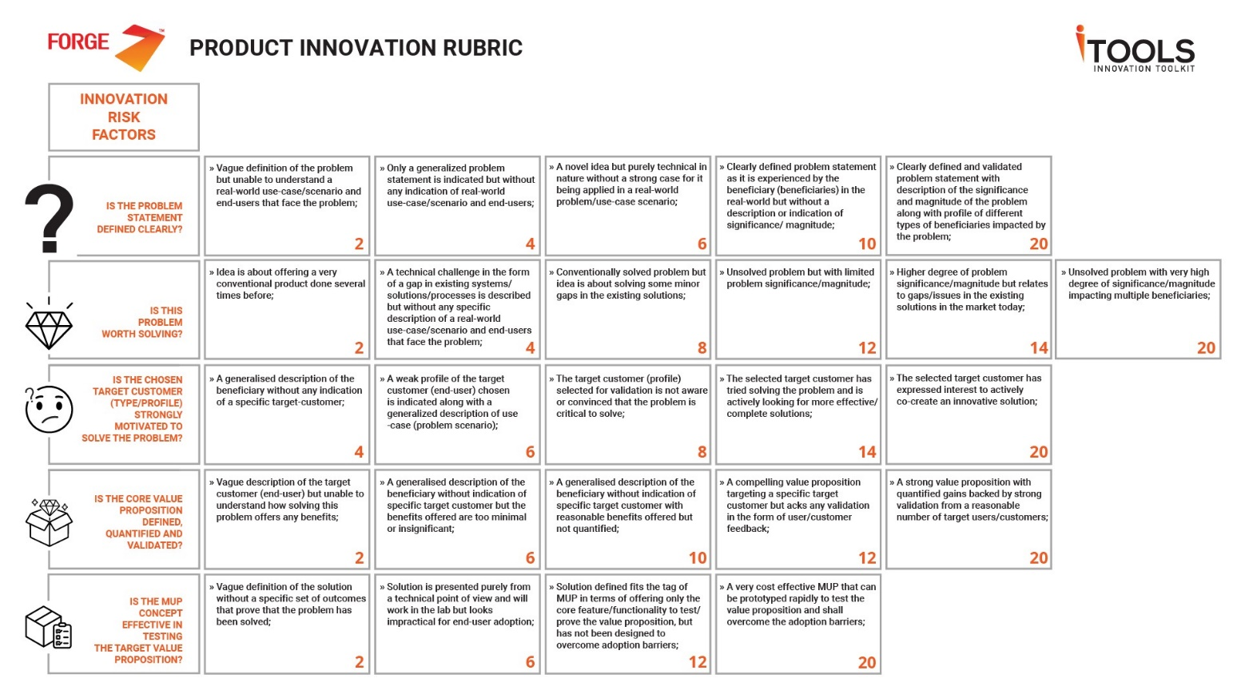

**5.2 PRODUCT INNOVATION HYPOTHESIS**

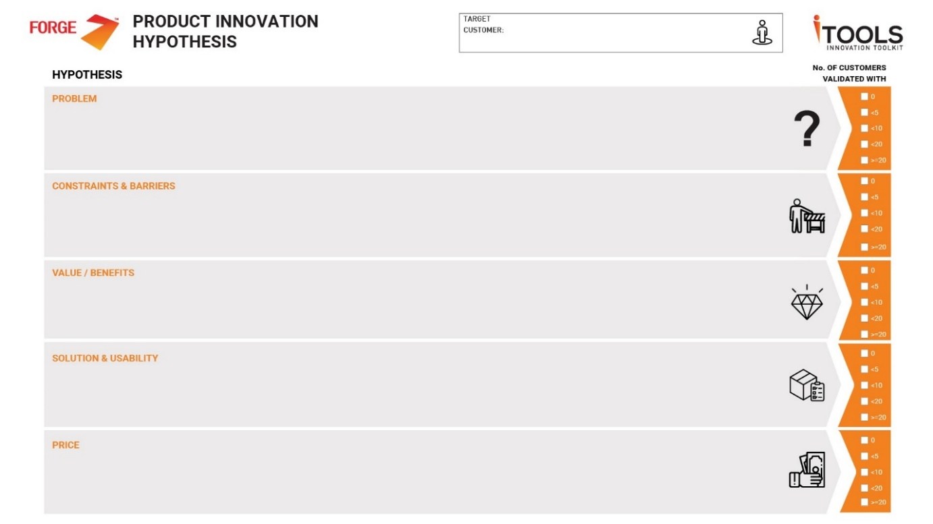

**5.3 INNOVATION FRAMEWORK**

**FLOW CHART**

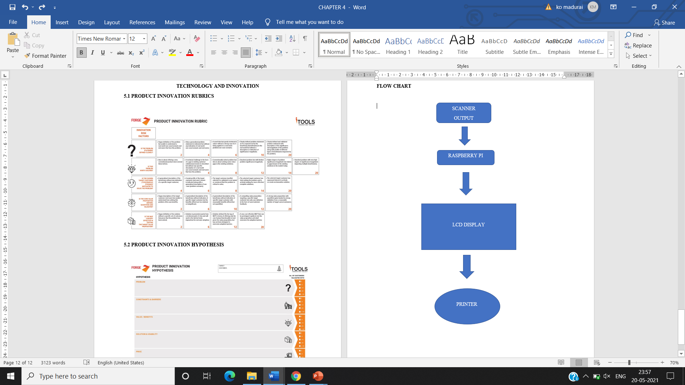

**5.4 TECHNOLOGY TO BE USED**

Raspberry Pi is a microcontroller board with low cost and based on the performance it is very high. And also, this microcontroller board have a flexible digital interface. The key features of the raspberrypi microcontroller are discussed in below:

* RP2040 microcontroller chip designed by Raspberry Pi in the United Kingdom.
* Dual-core Arm Cortex M0+ processor, flexible clock running up to 133 MHz.

The Raspberry Pi is a low-cost microcontroller and also called as credit-card sized computer that plugs into any applications like laptop, computer monitor or TV, and **uses** a standard keyboard and mouse. It is a capable little device that enables people of all ages to explore computing, and to learn how to program in languages like Scratch and Python.

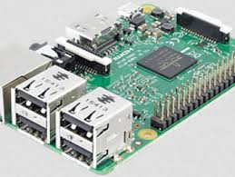

Figure 5.3: Raspberry pi microcontroller

**5.5 TEAM COMPETENCY**

The overall machine fabrication process is consisting of designing, framework, programming, simulation and electrical connection.

* G. G. SANJAI – Microcontroller, Electrical wiring, Programming logic.
* S. SANJAYAN – Mechanical frame work, Solid works.
* D. PARAVEEN KUMAR – Electronic components interfaces, Electrical wiring.

These are the work we are done together for make our product effectively with the help of some software, mechanical design & framework and by using interface of some electronic components.

**5.6 BARRIERS IN ADOPTING THE INNOVATION**

* It is very challenging to interface the raspberry pi microcontroller with the barcode scanner, display and printer.
* It is very difficult to implement the net banking like Gpay, amazon pay, paytm in this product.
* If the scanning of barcode in the products is not scanned very well means we can’t forward towards further proceeding like billing and payment.
* We can’t able to monitor the loyalty of the individual customer. So we need to go for one small checker.

**5.7 CONCEPT**

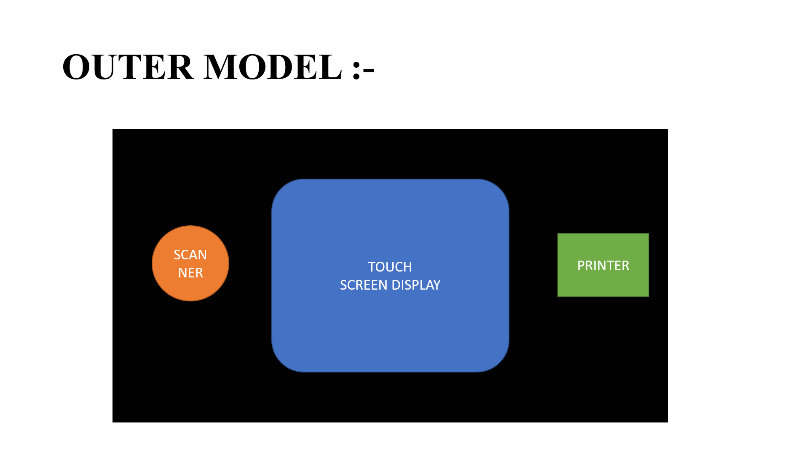

Figure 5.4: Block diagram of front view

* Here the fig 5.4 shows the block diagram of the front view of our proposed project.
* Inside there is a microcontroller which perform all the task as we programmed in that.
* There is one barcode scanner in the left side of the product.
* The customer wants to show the barcode of their purchased product one by one on the barcode scanner correctly.
* The barcode scanner recognizes the product and send the details of the product to the microcontroller through some signal.
* The microcontroller receives the information from the scanner and display the details on the screen with total amount of their purchased product.

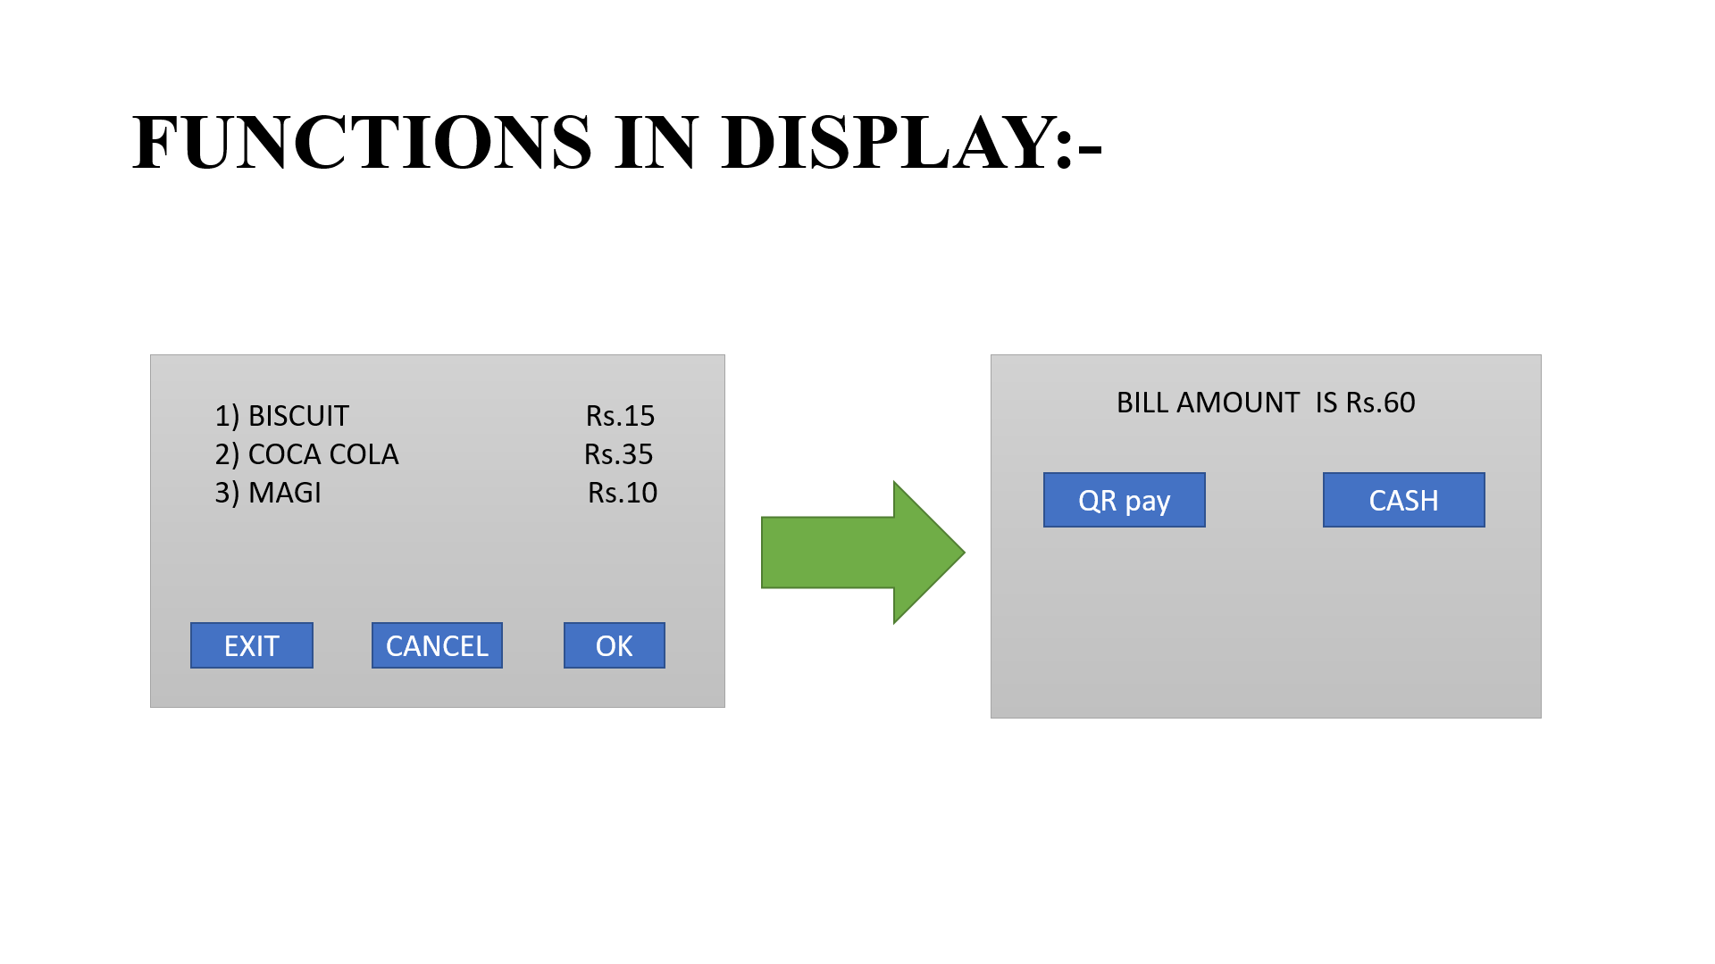

Figure 5.5: Details displayed in the screen

* In the fig 5.5 we can able to see the information of the purchased product and also the total bill amount of the products.
* After that if we need to remove any one of the products in the screen means we can remove that product with the help of remove option which is displayed on the screen.
* And also, we can cancel all the products and we can able to exit from the billing by using cancel and exit option which is present in the screen.
* If we done all the scanning process means then we click the ok button for further secured transaction proceeding for settle our bill.
* The microcontroller gets the transaction information and after verify the payment only it gives signal to the printer to print their bill followed displaying by some thank you for purchasing quotes in the screen.
* This is the concept of our proposed product.